Table of Contents
Preliminary Exploratory Data Analysis 2
Summary Statistics 2
Data Cleaning 3

Preliminary Exploratory Data Analysis
First, I conducted careful text extraction to handle regular paragraphs, tables, headers and footers and text that are inside of docx text boxes.
Then I examine each of the files’ sizes, word count and line count as part of their metadata.
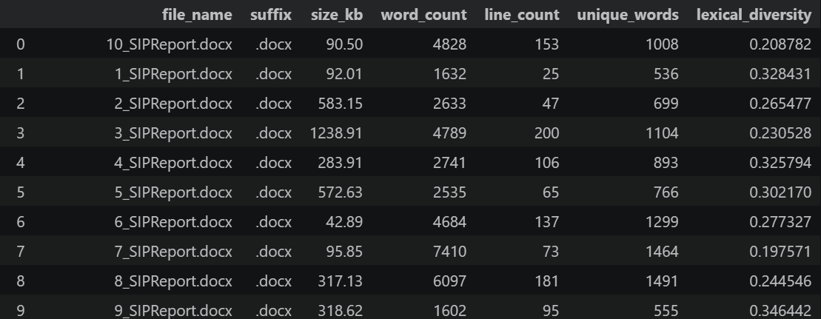
From the table, we can see that the 3rd report has the biggest file size of 1238.91 KB, whereas the 6th report is only 42.89 KB. This suggests that the 3rd report has a lot of images rather than just text and could be a Big Data & Analytics student depicting charts as images. In the 7th report, it has the highest word count of 7410 and a very low diversity score of 0.197. The 9th report has a low word count but the highest diversity (0.346), suggesting a very concise and vocabulary-rich document. There are also some noticeable outliers. The 1st report only has 25 lines for 1632 words, indicating high density as it is estimated to be 65 words per line which is very lengthy. After checking the 3rd report, it is confirmed that it contains high-resolution images of charts compared to other reports, making it an outlier in terms of file size.

Summary Statistics
Looking at the mean and median of the word count and size, the word count mean (3954) is higher than the median (3712) and the size mean (363.5) is also higher than the median (300.5). This trend is seen across the rest of the variables, showing that the data is right-skewed where there are a few large reports that are pulling the average upward. Looking at the standard deviation, we notice that the word count is relatively high to the mean, suggesting that some students are writing significantly more than others. There is also a lower standard deviation for lexical diversity (0.05) indicating that there is a highly uniform level of vocabulary complexity across all the reports despite differences in report length and file size.
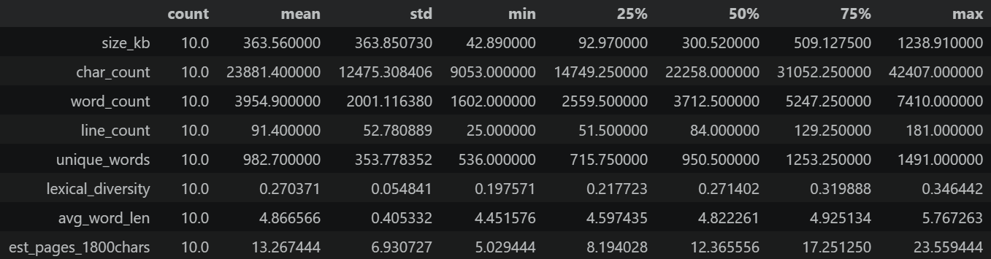

Data Cleaning
I briefly examined the reports and found that the sentence structure for most of the reports do not have grammatical errors. I applied the following data preprocessing steps to prepare the data for analysis:
- Lowercase all text
To standardize text and reduce noise, all documents were converted to lowercase.
- Remove URLs
A regular expression was applied to identify and strip out any embedded URLs.
- Remove punctuation and special characters
Text was filtered using a regex pattern to remove all special characters, retaining only standard alphanumeric characters, spaces and apostrophes to preserve basic word structures.
- Tokenize into sentences and words
Documents were split into distinct sentences based on periods and newline characters. Each sentence was then tokenized into individual words using whitespace delimiters.
- Remove stopwords
A comprehensive, hardcoded set of standard English stopwords was utilized to filter out low-value words. Additionally, a length filter was applied to drop any tokens that were 2 characters or shorter. A strict alphabetic filter was also enforced to remove stray numeric or mixed-character tokens.
- Apply stemming/lemmatization
A custom rule-based stemming function was applied to target words longer than 4 characters and stripped common English suffixes. This is to consolidate varying word forms into a common base representation.
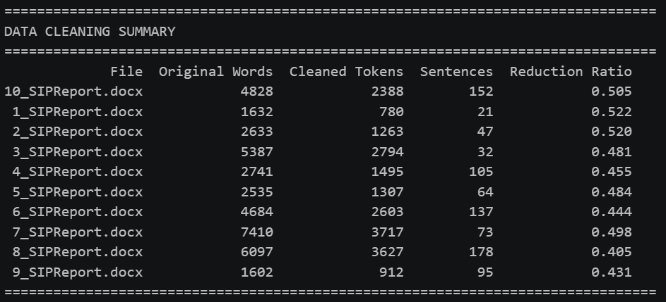
The preprocessing pipeline was mapped across the entire corpus using pandas, generating a cleaned version of the text alongside token and sentence counts. To evaluate the efficiency of the pipeline, a Reduction Ratio was calculated for each document by comparing the final cleaned token count against the original word count. This metric demonstrated the amount of noise removed from the dataset, preparing a highly refined text corpus for the subsequent exploratory text analysis phase.

Corpus Profiling and Frequency Analysis
To establish a baseline understanding of the dataset’s vocabulary, NLP tokenization was conducted across the corpus. A simple term frequency analysis was conducted across the corpus to identify the most dominant keywords.
- The Dominance of “Domain Stopwords”
In the frequency bar chart below, we can observe that there are generic terms to the context of an internship program rather than specific to what the students did. The most frequent words are student, internship, report, company, week and time. These words carry very little analytical value, and it will be hard to distinguish if the vocabulary is fed into a Topic Model as every topic will likely feature these words.
- Strong Technical and Systems Orientation
Looking at the frequency bar chart, the most frequent key words are data, system, project, process and develop. This shows that the students are engaged in technical, analytical or development roles. The high frequency of data and system suggests that data management, system engineering or analytics are primary functions in the internships across the reports.
- Action and Outcome Focus
We observe high frequency words like work, task, management, learn, team, business, shows that the tasks assigned to the students are experiential and task oriented. The students are also applying their technical skills within a corporate framework, not just doing isolated coding exercises.
- Residual Noise
There are more stopwords that were missed out from the initial data cleaning process such as also, use and new. Another round of data cleaning would be conducted to exclude generic adverbs and verbs, keeping only nouns and highly specific verbs.

This provided an initial, high-level view of the primary subjects discussed by the students before applying more complex weighting algorithms.
